

Practices for Secure Software Report

Table of Contents
Document Revision History 3
Client 3
Instructions 3
Developer 4
1. Algorithm Cipher 4
2. Certificate Generation 4
3. Deploy Cipher 4
4. Secure Communications 4
5. Secondary Testing 4
6. Functional Testing 4
7. Summary 4
8. Industry Standard Best Practices 4

Document Revision History

Version | Date | Author | Comments
1.0 | 04/14/2026 | Drew Lane Zinck II

Client



Instructions

Submit this completed practices for secure software report. Replace the bracketed text with the relevant information. You must document your process for writing secure communications and refactoring code that complies with software security testing protocols.

- Respond to the steps outlined below and include your findings.
- Respond using your own words. You may also choose to include images or supporting materials. If you include them, make certain to insert them in all the relevant locations in the document.
- Refer to the Project Two Guidelines and Rubric for more detailed instructions about each section of the template.

Developer
Drew Lane Zinck II

Algorithm Cipher

I recommend using AES-256 as the encryption cipher for Artemis Financial due to it being a trusted industry-standard algorithm that is known for providing strong protection for sensitive financial data. AES (Advanced Encryption Standard) is used to secure data at rest and in transit because it is efficient, reliable, and widely supported. Since the company handles personal and financial records, AES-256 is the right choice for protecting confidentiality. AES-256 uses a 256-bit key, this makes brute-force attacks extremely difficult with current technology. In addition to encryption, SHA-256 can be used as a hash function to verify data integrity through checksum validation. Unlike encryption, hashing is one-way and is used to confirm whether data has been changed. SHA-256 produces a fixed 256-bit digest that helps detect tampering. Random numbers are important in encryption as they are used to generate secure keys and initialization values. AES-256 is a symmetric-key algorithm, this means the same key is used for encryption and decryption. Non-symmetric, or asymmetric, encryption uses a public key and private key pair and is generally used for authentication, certificates, and secure key exchange. Many secure systems use both methods together as we should here. Encryption has evolved from early manual ciphers to modern computer-based standards. Older algorithms like DES became outdated due to their key sizes being far too weak. AES replaced older standards and became the modern benchmark for secure encryption. Today, strong encryption depends on modern algorithms, large key sizes, secure random number generation, and proper key management.

Certificate Generation
I generated a new self-signed SSL certificate using the Java keytool utility and stored it in a PKCS12 keystore file named keystore.p12 inside the project folder. The certificate was created using RSA with a 2048-bit key size and a validity period of 365 days. I also configured the certificate common name (CN) as localhost so it would align with local HTTPS browser testing. Once the certificate was created, I exported it from the keystore as a CER file named server.cer. I then opened the file in Windows Certificate Viewer to confirm the certificate details, including that it was issued to localhost and was self-signed for development use. 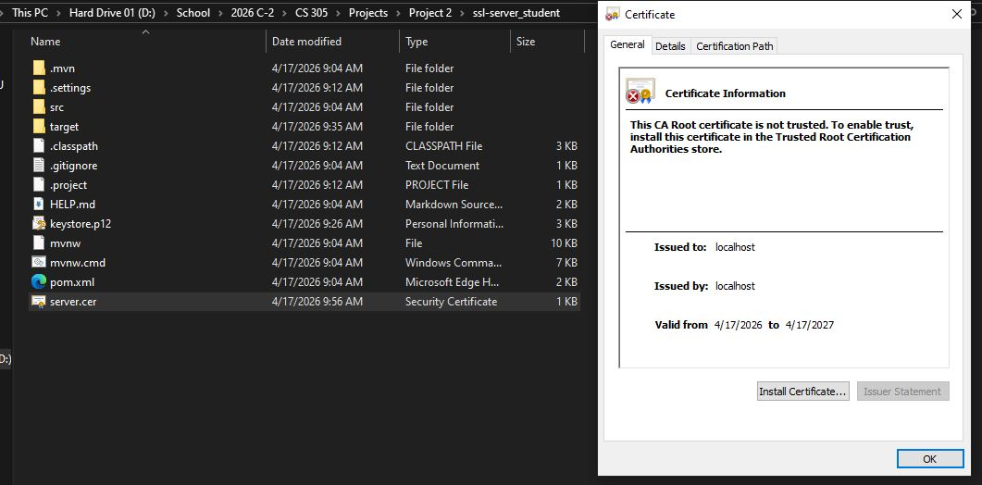

Deploy Cipher
I refactored the SslServerApplication.java file to implement the cryptographic hash algorithm by adding secure checksum functionality. I converted the class into a web controller using the @RestController annotation and created a new /hash route with @GetMapping. When the route is accessed, the application creates a SHA-256 checksum from a unique data string containing my name and project reference text. The program converts the hash output into hexadecimal format and returns both the original data and checksum result to the browser. I verified functionality by opening the checksum route in a web browser. The page displayed my name, the unique data string, and the generated SHA-256 hash value, confirming that the checksum verification worked correctly after refactoring.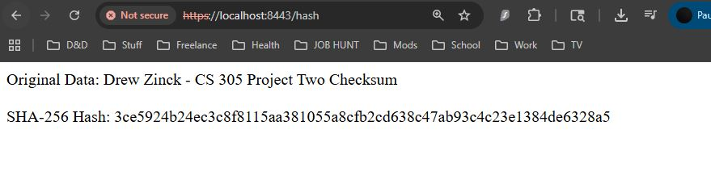
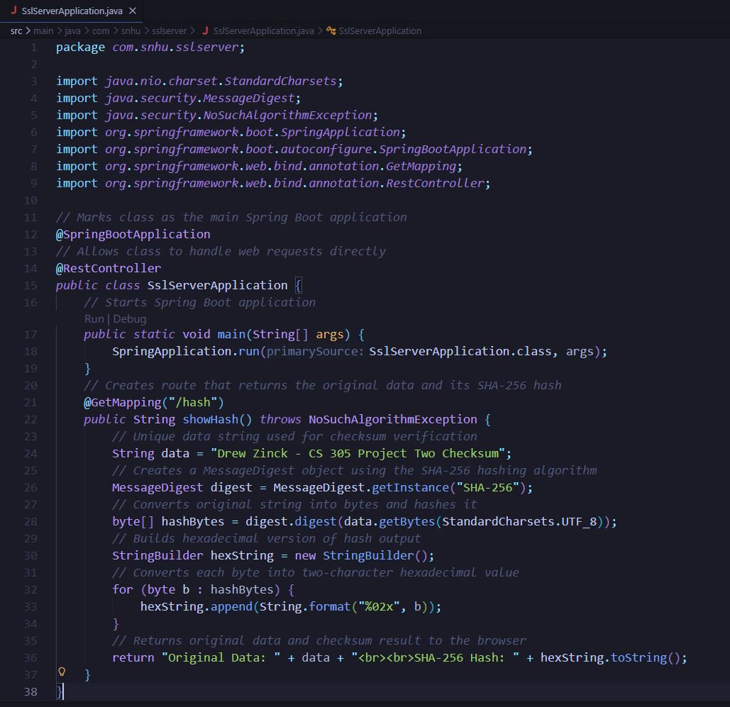

Secure Communications
I updated the application.properties file to convert communication from HTTP to HTTPS by enabling SSL settings for the Spring Boot application. I changed the server port to 8443 and configured the keystore file, certificate alias, password, and PKCS12 keystore type. These changes prepared the application to run securely over TLS/SSL instead of standard HTTP.

After compiling and running the refactored application, I opened https://localhost:8443/hash in a web browser. The secure webpage loaded successfully and displayed the checksum route output, confirming that encrypted HTTPS communication was functioning correctly.

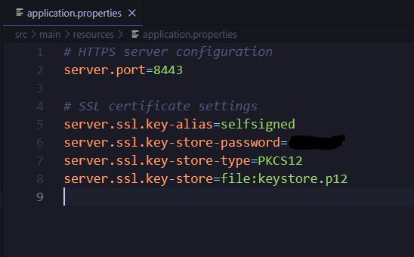

Secondary Testing
I performed secondary static testing on the refactored application using the OWASP Dependency-Check tool. The refactored application executed successfully without runtime errors, and the dependency-check scan completed with an HTML report for review. The results identified vulnerabilities in preexisting starter project dependencies, while the newly added checksum and HTTPS refactoring did not introduce additional third-party dependencies or new known vulnerabilities.
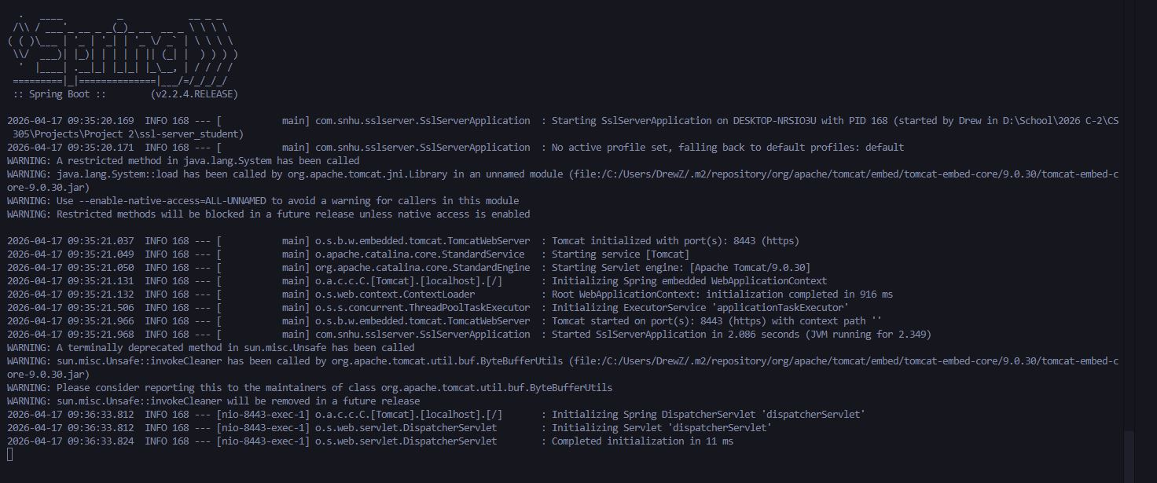
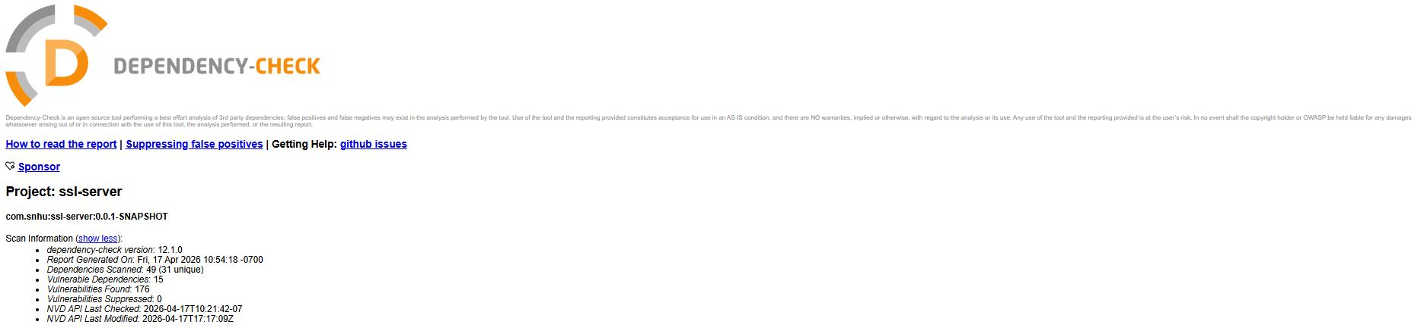
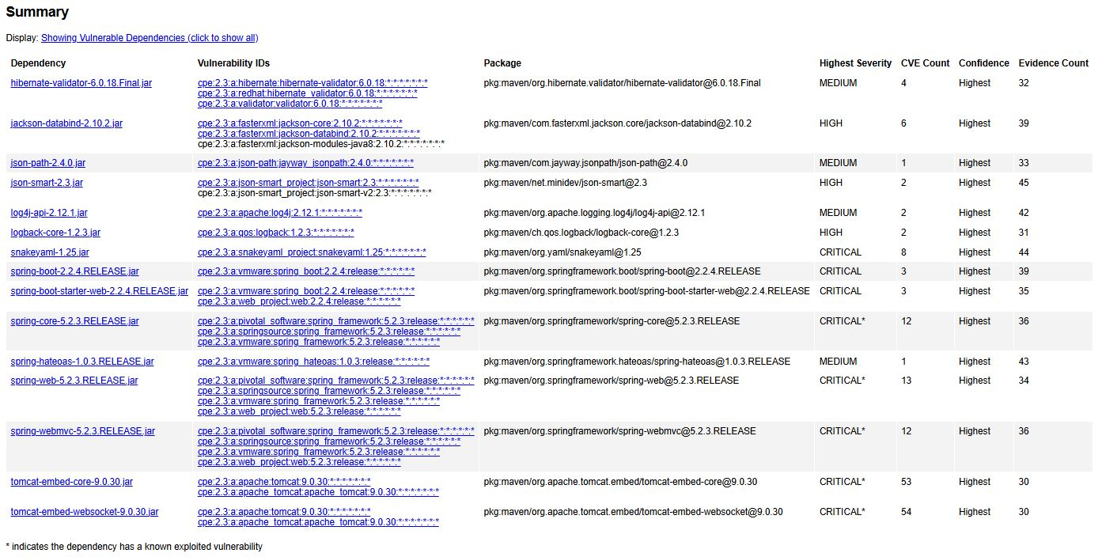
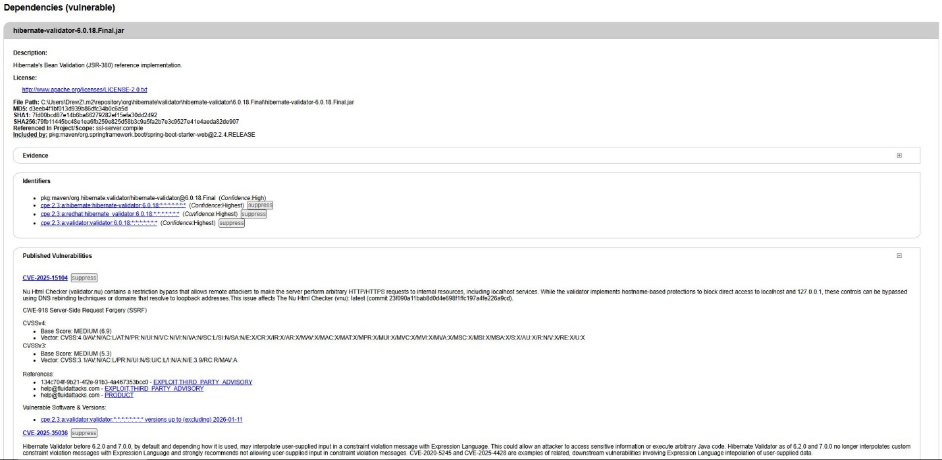

Functional Testing
I completed functional testing by manually reviewing the refactored application for syntactical, logical, and security vulnerabilities. The code compiled and executed without syntax errors, the application logic correctly generated a SHA-256 checksum from the unique data string, and HTTPS communication functioned properly through the secure browser route. I also verified that the refactored code did not introduce additional third-party dependencies or new known vulnerabilities.



Summary

In this project, I improved the security of the provided Spring Boot application by implementing several secure software practices. I generated a self-signed certificate, configured the application to use HTTPS communication, and refactored the code to add SHA-256 checksum functionality. These changes improved data integrity and secure communication within the application. I also completed testing through manual functional review and the OWASP Dependency-Check tool. The application executed successfully without runtime errors, and the checksum route functioned correctly through the secure browser connection. Dependency-Check identified vulnerabilities in several preexisting third-party dependencies from the starter project, while the newly added refactored code did not introduce additional known vulnerabilities. This project helped me understand how encryption, certificates, secure communication, hashing, and software testing work together to improve application security. I learned a lot and enjoyed the struggles to gain that knowledge.

Industry Standard Best Practices

Several industry standards best practices were used during this project. Secure communication was implemented by converting HTTP to HTTPS through SSL/TLS configuration and certificate usage. Data integrity practices were improved by implementing SHA-256 checksum verification to help detect unauthorized changes to transmitted data. I also followed secure software maintenance practices by performing dependency scanning with OWASP Dependency-Check to find known vulnerabilities in third-party libraries. This showed the importance of keeping frameworks and dependencies updated, especially older components inherited from existing projects. Other best practices included testing the application after refactoring, verifying successful execution, documenting configuration changes, and avoiding the introduction of unnecessary dependencies. Together, these practices help reduce security risk and improve long-term software reliability.

